ST. MARIA GORETTI CATHOLIC
HIGH SCHOOL FINANCIAL
ASSISTANCE POLICY

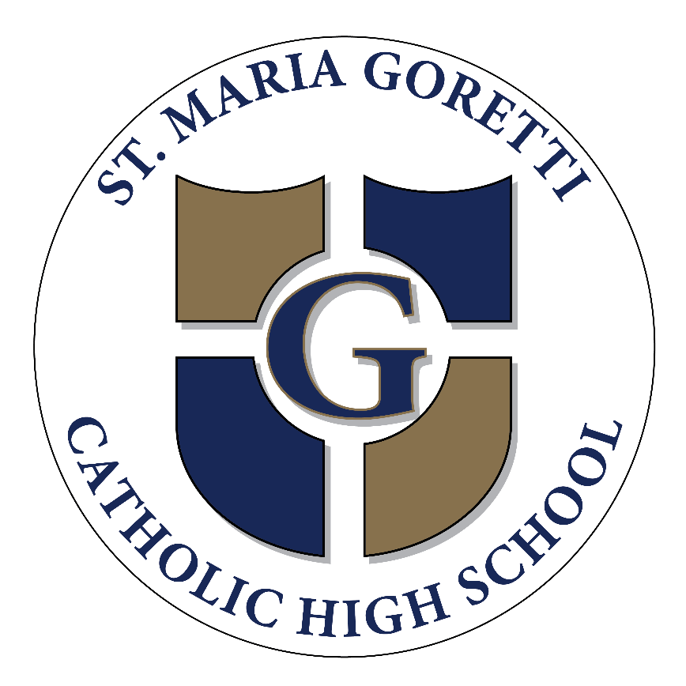

ST. MARIA GORETTI CATHOLIC HIGH SCHOOL FINANCIAL ASSISTANCE

St. Maria Goretti Catholic High School’s financial assistance program provides need-based grants to assist qualifying families who cannot meet the full cost of tuition. If a family chooses to apply for financial assistance at St. Maria Goretti Catholic High School, financial assistance is considered based on a family’s demonstrated need and the availability of school funds.
Financial assistance decisions are made independent of admission decisions.
The foundation of our program emphasizes the following “Principles of Good Practice for Financial Aid" of the National Association of Independent Schools (NAIS) in the administration of financial aid:
• The School determines eligibility for admission without regard to a student's application for financial aid.
• The School commits to providing financial aid dollars to applicants who demonstrate that their family resources are insufficient to meet all or part of the total educational costs.
• The School continues to provide support to students as long as financial need is demonstrated.
• The School enacts documented procedures that ensure a fair, consistent, and equitable assessment of each family's ability to contribute toward educational expenses.
• The School safeguards the confidentiality of financial aid applications, records, and decisions.
St. Maria Goretti Catholic High School subscribes to FACTS which assists schools in making financial aid decisions. The purpose of FACTS is to establish an equitable and consistent approach to the distribution of funds for independent schools throughout the United States. Schools using FACTS rely upon a standard methodology to assess the financial strength of a family, that is, the resources available to contribute toward a child's educational expenses. Parents submit detailed financial information to FACTS which in turn processes the information according to established standards and procedures. A family’s financial situation will be evaluated, and an estimated award for tuition will be recommended by FACTS. The result of the evaluation is sent to St. Maria Goretti Catholic High School. In processing the application, FACTS takes into account many factors, including income, assets, expenses, indebtedness, family size, age of parents, and the number of children attending tuition-charging schools.
FACTS considers these factors and provides every family with a living allowance based upon family size. This allowance protects a certain amount of income after a variety of expenses are already subtracted from a family's income. This process helps determine a family's discretionary income. A portion of this discretionary income is then suggested as the family contribution for education. The more discretionary income a family has, the higher the family's contribution.
St. Maria Goretti Catholic High School ’s Financial Aid Committee evaluates the suggested contribution from FACTS in light of its understanding of the limitations and biases of the computational model, as well as information from tax returns and other family circumstances of which it may be aware. Responsibility for all financial assistance awards rests solely with St. Maria Goretti Catholic High School and it’s Board of Trustees.
Awards are contingent on maintaining compliance with the Enrollment Contract and other written agreements as well as being current at all times with any and all financial obligations to the School. Failure to comply with contract and financial obligations will result in revoking financial aid. Families should notify the business office of any changes in income. An application for aid must be submitted each year, regardless of previous assistance.
Families may also apply for additional financial assistance through the Archdiocese of Baltimore and BOOST and the amount of financial assistance granted by SMGCHS will take into account any such assistance.
II. FINANCIAL ASSISTANCE POLICIES
A. APPLICATIONS
Families must complete an online FACTS application and submit requested documentation including tax returns in a timely manner. Financial aid is awarded on a first come, first serve basis.
B. RETURNING STUDENTS
All returning students must have submitted their re-enrollment contracts and have paid the required deposit to reserve their place for the upcoming school year in order to be considered for financial assistance.
If the financial assistance award is insufficient for the student to be able to return to St. Maria Goretti Catholic High School, the family will be given a period of time to withdraw (in writing) from the enrollment contract without an obligation to pay the tuition and with full refund of the deposit.
C. NEW STUDENTS
New students must have been admitted to the School and enrolled before an application for financial assistance can be considered. If the financial assistance award is insufficient for the student to be able to attend to St. Maria Goretti Catholic High School, the family will be given a period of time to withdraw (in writing) from the enrollment contract without an obligation to pay the tuition and with full refund of the deposit.
Students joining St. Maria Goretti Catholic High School during the second semester will not be eligible for financial aid.
D. CAP ON FINANCIAL ASSISTANCE AWARDS
For each academic year, the Financial Aid Committee has a maximum cap of 75% of tuition for all financial assistance awards. This policy will be reconsidered annually. All applicants should consider this carefully when making application and determining payment options. This means that no student will pay less than 25% of the stated tuition unless such tuition is approved by the Board of Trustees.
E. UNEMPLOYED PARENT
The School expects both parents to contribute to tuition. If one parent is unemployed, is not disabled and does not have extenuating circumstances, three fourths of the School’s tuition will be added to the income of the family for the calculation of need. The presumption of the Financial Aid Committee will be that that parent has the opportunity to work at least part-time to contribute toward the school tuition. Families with pre-school aged children and/or elderly family members in the home should make the School aware of their circumstances.
F. DIVORCED AND SEPARATED PARENTS
In the case of divorce or separation, the School requires both parents to file an application for Financial Assistance. All current tax returns and supporting documentation are required from both parents. The School is not bound by any divorce agreement specifying a parent's responsibility for educational expenses. It is felt to be unfair for the School to subsidize a child's education if one of the parents is able, but unwilling, to contribute to his/her child's tuition. It is also the School's policy to consider the resources of a step-parent in making an award.

G. BUSINESS LOSSES AND NON-CASH DEPRECIATION
Business losses and expenses that do not affect cash flow (such as depreciation and home office write-offs) may be disallowed when computing financial need.
H. DELINQUENT ACCOUNTS
Financial assistance will not be awarded to any student whose present account balance is delinquent. If the account balance becomes delinquent after the financial assistance award has been made, the School reserves the right to withdraw the award if the account is more than 30 days past due.
I. STUDENT IN GOOD STANDING
To be considered for financial assistance, students must be in good standing academically and behaviorally while parents must understand and support the mission of the school.
J. APPLICATION DISCREPANCIES
Should discrepancies and/or inaccurate information be discovered in the information provided to St. Maria Goretti Catholic High School, the School reserves the right to withdraw financial assistance at any time during the school year. It is the responsibility of the parent(s) to notify the School immediately if any error or discrepancy has been submitted to FACTS and/or to St. Maria Goretti Catholic High School.
K. OTHER SITUATIONS AND INFORMATION
Financial assistance is granted only for tuition. It does not cover application fees, deposits, activity fees, uniforms, lunches, field trips, tutoring, screenings, tests, summer reading program, or after school enrichment programs.
Families must apply for financial assistance each year, regardless of previous assistance. Parent(s) should notify the business office of any changes in income. St. Maria Goretti Catholic High School reserves the right to request additional financial information from the applicants at any time.

III. APPLICATION PROCESS AND TIMETABLE
A. ROLE OF THE FINANCIAL AID COMMITTEE
St. Maria Goretti Catholic High School’s Financial Aid Committee is comprised of the President, the Director of Finance, the Principal and the Director of Athletics with governance by the Board Finance Committee (whom are not current parents). All of the financial assistance applications are considered confidential. Only the staff members of St. Maria Goretti Catholic High School and the Board Finance Committee have access to this information.
B. THE FINANCIAL ASSISTANCE PROCESS
1. Parent(s) may complete the FACTS application online. Payment is made online at the end of the application.
2. Parent(s) must provide FACTS with copies of all required documentation. The support documents can be mailed or scanned in PDF format and emailed.
3. Upon receipt of the application by FACTS, the School will be notified of your application.
4. Once FACTS has received all required documentation, the application will be deemed complete.
5. A comprehensive, financial summary of all applicants are forwarded to the Financial Aid Committee for consideration. The Financial Aid Committee reviews and assesses the need for financial assistance and whether or not the application meets the financial assistance objective of St. Maria Goretti Catholic High School and all policies as described herein. The FACTS report is used as a guideline for making decisions but is not the sole determining factor.
6. Financial assistance awards are determined by the Financial Aid Committee and, when appropriate, the Finance Committee and the Board. The families are notified in writing of the tuition award amount.
• The letter will identify whether or not the applicant received an award and if so, the amount of the award.
• For those students who do not receive an award, the parent(s) will receive a tuition agreement to submit to the School by a specified deadline.
• For those students who receive an award, the letter will specify a deadline for accepting or declining the award. If the response is not received by the deadline specified in the letter, the financial assistance funds will be released to help other applicants. If the parent(s) accepts the award, the parent(s) will receive a tuition agreement that is adjusted to reflect the award amount.
C. REQUIRED DOCUMENTATION
1. All Parents who choose to apply for financial assistance must do so through FACTS application online.
2. Copies of the prior year’s complete tax returns (including all schedules and copies of all W-2s) must be provided. All tax returns must be signed. Parents must submit a complete tax return. In order to ensure a timely review of the financial aid application, parent(s) are advised to prepare their federal income taxes before March 1st.
3. Parents who own private businesses or farms will be required to furnish a copy of the business’ current tax return. Cash flow statements, balance sheets, and other information relevant to the business may be needed by the School as well.
4. Military families should furnish a copy of the Leave and Earnings statement.
5. If a student has assets in a trust fund, parents must furnish a copy of the Trust agreement.
6. In the case of separated or divorced families, the custodial parent and, if applicable, the present spouse, should complete the application online as described above. The non-custodial parent should complete and send their own separate application to FACTS. If the non-custodial parent refuses to submit the necessary information to FACTS, it is possible that the financial assistance application will not be processed. If it can be documented that the non-custodial parent is absent or non-supportive, this requirement may be waived.
7. In situations where couples are living together but not married, the School requires financial information from both parties. This may be consolidated in one application or done in two individual applications. If the child is from a former marriage of either parent, forms will be required of current family and non-custodial parent and spouse, if applicable.
8. If the child is part of the family due to adoption or artificial insemination, forms will be required as with any two-parent family.
9. If there is another family member enrolled in an independent school or a college/university, written documentation of an award for financial assistance for that individual at that school may be required.
D. OPTIONAL DOCUMENTATION
Some families have circumstances that impact their ability to pay tuition that are not reflected in all of the documentation provided. If the parent(s) believe that this is the case, the parent(s) is welcome to write a letter to the Financial Aid Committee describing these circumstances. While more information for the Financial Aid Committee is always more helpful than not, a letter is not a requirement for consideration for financial assistance.
E. FINANCIAL ASSISTANCE WAITING LIST
Once all financial assistance funds have been awarded, the School will maintain a waiting list of applicants who qualify for assistance but have not yet been awarded financial assistance.
F. FINANCIAL ASSISTANCE APPROVAL LEVELS
The Financial Aid Committee will use the recommendation of FACTS to determine initial awards. For each academic year, the Financial Aid Committee has a maximum cap of 75% of tuition for all financial assistance awards. The Financial Aid Committee will use FACTS to determine initial awards. If there are extenuating circumstances and the Committee feels that an award should be more than what FACTS has determined, they may award up to 25% of the stated tuition. For award exceeding 25% of the stated tuition and up to 50% of the stated tuition, the award must be approved by the Finance Committee. An award exceeding 50% of the stated tuition must be approved by the Board or its Executive Committee.
Once the financial assistance budget has been set and approved by the Board, no person shall be granted financial assistance without approval by the Financial Aid Committee.
G. FINANCIAL ASSISTANCE APPEALS PROCESS
If a family would like to appeal the amount they were awarded, they will complete a Google form and provide any additional information that is needed. After a review by the Financial Aid Committee, the appeal may be forwarded to the Finance Committee and/or the Board, depending on the amount of additional aid being requested. A formal response will be sent to the family via email.

Updated 2/25/2022

